UK Recovery Walk Shrewsbury 2018 – Travel Information

Shrewsbury is a historic medieval town which makes it an attractive visitor location. Its surrounded on three sides by the River Severn which means that transport into the centre can lead to some congestion and delays.

We would recommend travelling early to ensure you are parked at your preferred location and get to The Quarry Park in plenty of time and with minimum stress

Parking at any of the car parks will require some walking but with careful planning and the right choices for you or your family or group will help make your visit to Shrewsbury a pleasurable experience

What time do you need to be there?

The start time for the walk is midday from The Quarry SY1 1RW this means you will need to be in The Quarry by no later than 11.30am for pre-event opening ceremony

How are you getting to the Recovery Walk?

Shropshire Council would like to provide you with information to help you plan for your journey to and from the event

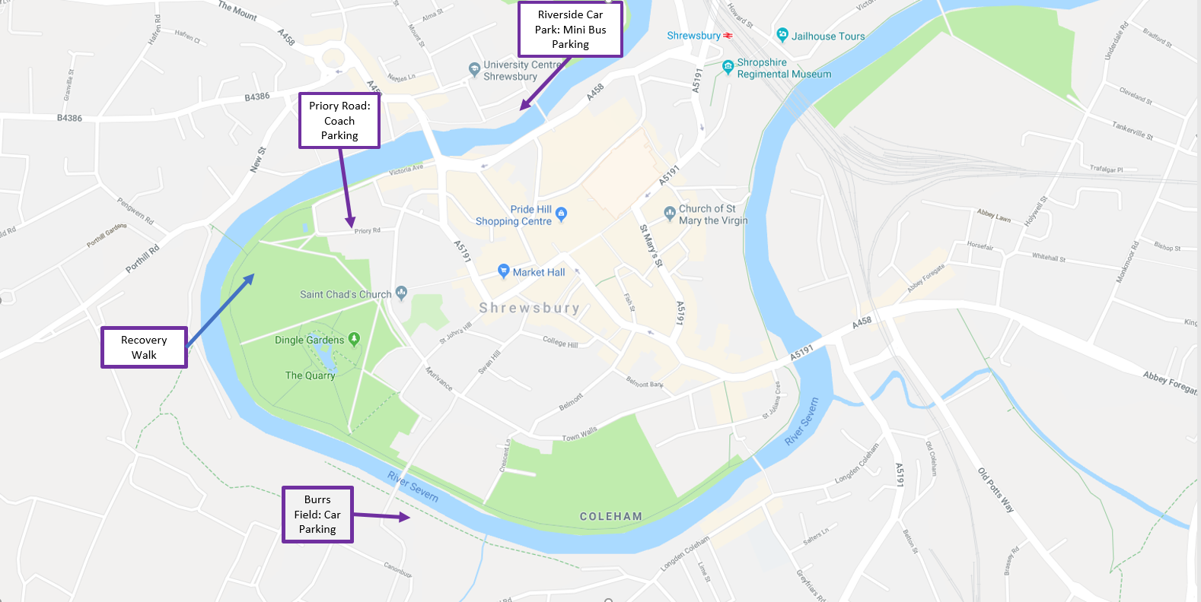

Travelling by Coach

If you are travelling by coach on an organised group trip we have identified specific areas for parking for this event.

To help us direct you to the best available location booking and to minimise issues booking is essential so please could you contact us to confirm if you would like a space by emailing zoe.mortimer@shropshire.gov.uk with details of the size of coach and expected arrival time

This will allow us to ensure we park you quickly and efficiently and if required identify a drop off point if the nearest spaces to the event start point are already booked

Bookings will be taken and coaches parked at the nearest location available

Priory Road

- Number of Spaces available is 14
- Walk to start point from parking is 5 minutes
- Coaches will remain parked at this location for pick up after the event
- Nearest toilets are in The Quarry Park

Abbey Foregate (Loop Road)

- Number of Spaces available is 20
- Drop off will be Priory Road and pick up will be St Chads Terrace
- Walk to start point from drop off is 5 minutes
- Walk to pick up point will be 5 minutes but at a different location to the drop off point

Travelling by Minibus

If you are travelling by minibus we have spaces for 40 mini buses at Frankwell Riverside Car Park, SY3 8HQ

Toilets will be available 1 x disabled and two standard units by the Frankwell Footbridge or Theatre Severn is adjacent the car park and has a lovely café and toilets on route towards The Quarry Park

To help us ensure we have sufficient spaces available please could you contact us to confirm if you would like a space by emailing zoe.mortimer@shropshire.gov.uk

Car Travel

It is essential that you plan your journey and arrive well in advance of the start time of the event and allow time for finding parking, finding a space and walking to the event

Traffic can be busy and difficult if you do not know the town due to one-way systems so we encourage you to plan well in advance of travel and allow for delays

Main roads into Shrewsbury are the M54 / M6 network or the A49, A5, A53, A458.

Burrs Field Designated Car Park – Postcode SY3 7AF

This temporary parking area on grass has been set up specifically for visitors for this event and can accommodate around 450 cars

Pedestrian routes to the Quarry Park are via steep varied depth steps via Kingsland Toll Bridge and it will take about 15-minute walk along the river paths

It is not suitable for wheelchair users or those who are challenged in walking terms

Town Centre Car Parks

There are several town centre car parks but these tend to get very busy particularly on Saturdays so please arrive in plenty of time. The parking charges are due to change on Monday 3rd September so please be aware that the pages have the current tariffs.

Car Parking will be subject to availability when you arrive, however we have identified the following pay and display car parks located near The Quarry and links where available to costs and post codes

Frankwell Main Car Park – http://shropshire.gov.uk/parking/find-my-nearest-car-park/shrewsbury-frankwell-main/

If full you are advised to use

Raven Meadows MSCP - http://shropshire.gov.uk/parking/find-my-nearest-car-park/shrewsbury-raven-meadows-multi-storey/

St Julian’s Friar’s Car Park – http://shropshire.gov.uk/parking/find-my-nearest-car-park/shrewsbury-st-julians-friars/

NCP Wyle Cop Car Park - https://www.ncp.co.uk/find-a-car-park/car-parks/shrewsbury-wyle-cop/

Abbey Foregate Car Park – http://shropshire.gov.uk/parking/find-my-nearest-car-park/shrewsbury-abbey-foregate/

The Gap Car Park, Raven Meadows, Shrewsbury, SY1 1PJ

Blue Badge Parking

Normal car parking charges apply for the designated disabled parking spaces in all the surface car parks with an extra hour on any parking ticket duration purchased

Park and Ride

Shrewsbury has three park and ride sites around the edge of the town and is the cheapest way to get to the town centre. Wheelchair accessible buses operate on routes and normal charges apply.

The nearest stops for the event are Barker Street and you can walk up a Claremont Hill by the Loopy Shrew Bar to The Quarry Park. Please alert the bus driver that you wish to disembark at this location.

Anyone with a valid English bus pass will be able to travel on the Shrewsbury park and ride service for half the price - that's only 80p return!

All day parking when purchasing a ticket - free. Return bus fare - £1.60 (please note: £1.60 single fare for walking passengers)

Group ticket - allowing up to five adults to travel after 9:30am Monday to Friday and all-day Saturday - £2.50

Accompanied children under 16 years – free

The frequency of the buses for this event will be every 12 minutes throughout the day and the number of passengers that can be taken is 70 passengers per journey

The first bus is at 8am on Saturday.

The last bus departs from the Barker Street Bus Stop at 6:20pm and drops off at named park and ride stops around the town centre

This is likely to be busy and travel time to the town centre is around twenty minutes although again at busy times this could increase or you may have to wait for the next bus after arriving by car so please plan your journey carefully

Harlescott - SY1 4HA
Meole Brace - SY3 9NB
Oxon - SY3 5AD

Please see a link to our park and ride for further details

https://shropshire.gov.uk/public-transport/park-and-ride/park-and-ride-shrewsbury/

Shirehall Car Park

There is free parking available at this location which can be used for the event if you fancy a stroll into the town centre which will take around 45 minutes or less if you catch the local service buses from Abbey Foregate

The nearest Bus Stop to the Shirehall is on Abbey Foregate on the opposite side of the road from the Shirehall.

The Cost of a Single is £2.40 and a return is our Local Day Saver Ticket at £4.20

The 23 service runs every 30 minutes at 16 and 46 of each hour
The 8/8a Service runs every 30 minutes at 12 and 42 of each hour,
The X4 service runs every hour at 27 past each hour,
The X5 Service runs every hour at 57 past each hour,
The 436 Service runs every hour at 21 past each hour, (Subject to change please follow the links to check service times)

Please see the links to the timetables copy them into your search bar and they will work.

https://www.arrivabus.co.uk/midlands/services/436---shrewsbury-to-bridgnorth/?direction=inbound
https://www.arrivabus.co.uk/midlands/services/x5-x4---shrewsbury-to-telford-town-centre/?direction=inbound
https://www.arrivabus.co.uk/midlands/services/8-8a---shrewsbury-to-tilstock/?direction=inbound
https://www.arrivabus.co.uk/midlands/services/23---shrewsbury-to-heathgates-judith-butts/?direction=outbound

The nearest stop for The Quarry is Barker Street near The Loopy Shrew Bar and Restaurant please ask the driver when you get on the bus that you require this stop

The nearest stop for returning to Shirehall is the Raven Meadows Bus Station SY1 1PL unless you purchase a Day Ticket which means you can return to the stop at Barker Street and select the service bus back to outside The Shirehall

Public Transport

Train

The nearest rail station is Shrewsbury and it is about a 15 minute walk to The Quarry.

Approximate train journey times to Shrewsbury are:

Birmingham: 1 Hour (Direct Train)
Manchester: 1 Hour 15 Minutes (Direct Train)
Cardiff: 2 Hours 30 Minutes (Direct Service)
London: 2 Hours 30 Minutes to 3 Hours (Some Direct Services)
Bristol: 3 Hours
Newcastle Upon Tyne: 4 Hours
Glasgow: 4 Hours 30 Minutes

For details on timetables please contact http://www.nationalrail.co.uk/stations_destinations/default.aspx

Plan your journey here with National Rail journey planner or call 08457 48 49 50.

Bus

Travel by bus and coach is stress-free and cost-effective.

For information and timetables call the Shropshire Travel Line on 0870 608 2608

There are many local services available for further information on the bus schedule and route, please visit: http://www.travelinemidlands.co.uk

Information is also available from
National Express (0870 580 8080)
Travel Line Midlands (0870 2002233) and
Severn Dee Travel (01691 681010)

Taxi

There is a taxi rank directly outside Shrewsbury Railway Station, alternatively you can call one of these local Shrewsbury taxi numbers:

If you're coming for a night out in Shrewsbury, don't forget to book your journey home to avoid long waits.
- Shrewsbury Taxis - 01743 244477
- Go Carz - 01743 441144
- Vincent Taxis - 01743 367777
- Access Cars - 01743 545454
- AAA Shrewsbury Taxis - 01743 244555
- Star Cars Travel - 01743 353535

