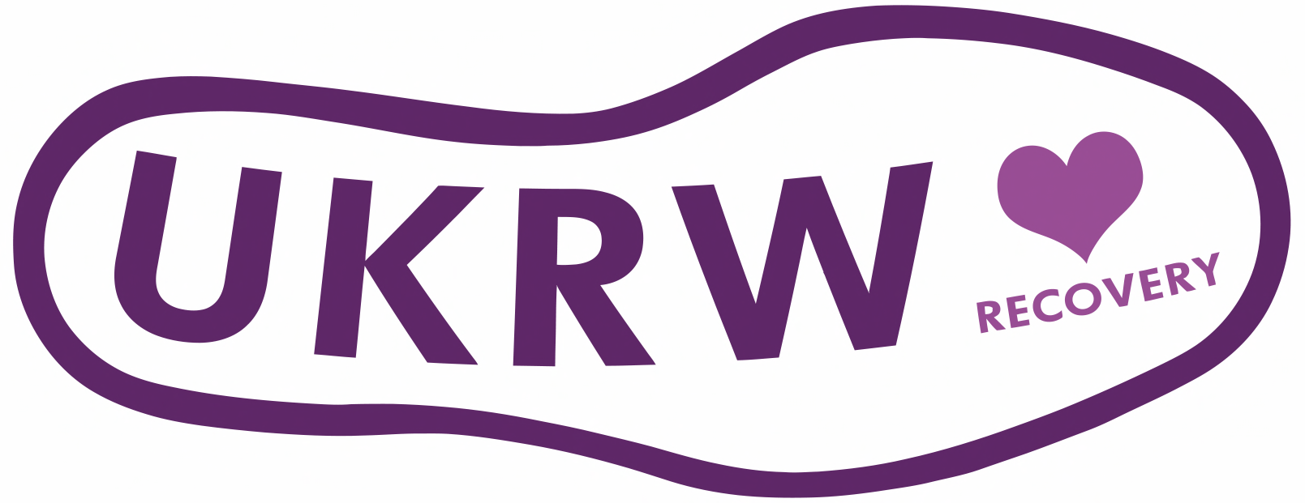

Partner/Sponsorship Information

UK Recovery Walk Shrewsbury 2018

The Charity

Faces & Voice’s of Recovery UK is a registered member-led charity supported by a Board of Trustees, the majority of whom are in recovery. We have ensured a good geographical spread in the representation of the Board of Trustees and have adopted a transparent and simple way in recruiting Trustees and Members.

The Charity is registered with the OSCR, (Office of the Scottish Charity Regulator) allowing the charity to operate in England, Wales, Ireland and Scotland. The charity practices good governance as recommended within the good practice guide produced by the OSCR.

Our goal

Our strategy is to remain focused upon supporting the delivery and sustaining the UK Recovery Walk. Throughout the year we will get involved in local events and help grass route initiatives to realise their dreams in getting their voices of recovery heard and their faces seen.

Our Mission

- To support people in recovery across the UK to connect and share in their recovery by taking part in the national walk and conference
- To provide various social media platforms to share news and stories
- To provide individuals with the opportunity to share their assets with others
- To act as a resource for those that are involved in planning recovery focused events

The Walks

The UK Recovery Walk which takes place each September, raises awareness of substance use disorders and RECOVERY from addiction. The point of The UK Recovery Walk is to celebrate the achievements of individuals in recovery, and acknowledges the work of prevention, treatment, and recovery service providers. The UK Recovery Walk attracts participants from around the UK, including key city officials, people in recovery and their friends and family, policy makers, health planners and purchasers of goods and services, representatives of industry and commerce, as well as managers, practitioners and users of health services.

The Conference

Will be open to 150 participants, the programme for the conference will include presentations from world leaders in the field of Addiction & Recovery and will comprise a wide range of subjects appealing to its diverse audience.

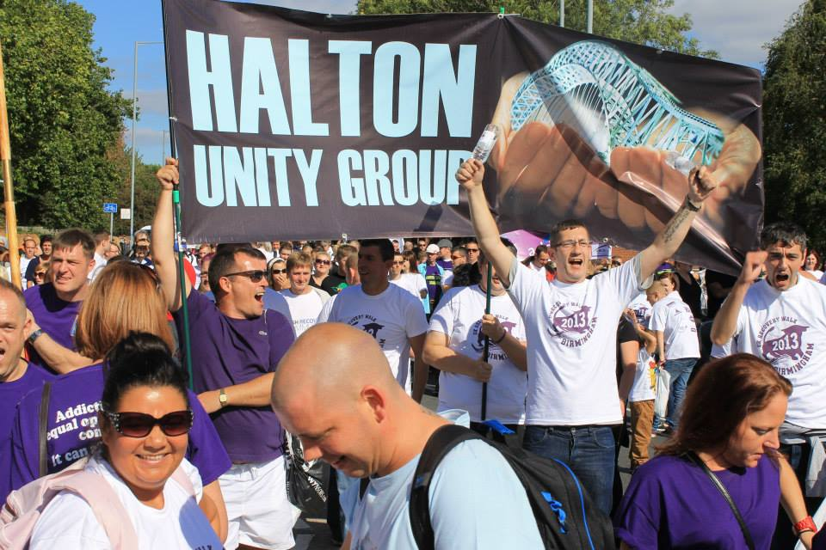

Partnership/Sponsorship Opportunities

Each year the Walk grows in attendance, stature and significance and UK Recovery Walk – This years Walk will be the biggest Walk to date. We are aiming for 8000 to 10000 participants. Attendance and reach is expected not only in UK-wide but far reaching across the globe in terms of the recovery movement.

The recovery community takes note of its supporters and friends, and, as such, partnering and sponsoring the event is a great way to not only reach those in your local area but reach a far wider audience that may not have been easily accessible to you before. Being associated with the Walk demonstrates organisational support for visible recovery and empowerment whilst also bringing benefits to the organisation through awareness raising and positive coverage within the treatment sector.

Benefits to getting involved

- Direct access to a number of leading lights within the recovery movement
- Promoting your organisation service and or products nationally and in the wider global recovery movement
- Enhancing your own marketing and media strategy
- Networking with likeminded individuals and organisations
- Association with a leading authentic UK recovery organisation

There are a number of ways to get involved in partnering, supporting and contributing to the Walk and Conference, outlined below.

Opportunities and packages available.
Conference, Walk and Post Walk Celebration & Exhibition
Main Recovery Partner £15,000 (Package 1, see below)
Recovery Partner £7,500 (Package 2, see below)

Conference
Primary Conference Sponsor £10,000*
Conference Sponsor From £2,500^
Exhibition Spaces From £750*
Conference Reception From £3,000*
Session Investor Negotiable
Delegate Bags From £500*^

Walk
Primary Start Line Sponsor £8,000*
Start Line Sponsor £5,000^

Post Walk Celebration & Exhibition
Primary Stage Sponsor £5,000*
Stage Sponsors £3,000^
Exhibition Stall £1,000~

*Included in Main Recovery Partner Package
^Included in Recovery Partner Package
~Free to small community groups and organisations

Event Programme
Free, full colour, A5 Conference and Walk programme given to all conference attendees, walk participants and distributed to the general public on the day. It’s envisaged around 8,000 of these will be printed. In addition to highlighting the events and celebrations, there will be features and spotlights on recovery, addiction help information, features on advertisers, news and promotions included in the programme.

Package 1 - Main Recovery Partner
Main Recovery Partners are acknowledged across all communications including:

- Primary Start Line Advertising (own banners need to be provided)
- Full-page, full-colour advert in the Event Programme
- Main Recovery Partner’ branding on Walk website, on appointment until 30th September 2018
- Full page content on Walk website with logo link from home page
- Exhibition stall at Conference and Post Walk Exhibition & Celebration
- Acknowledgement on all press releases

Package 2 – Recovery Partner
Recovery Partners are acknowledged across lots of communications including:

- Start Line adverts(own banners need to be provided)
- Half-page advert in the Event Programme
- Recovery partner branding on website
- Listed on website as a Recovery Partner
- First Option on further promotions and advertising

NOTES

Pre-conference exposure, via the alerts sent to over 15,000 individuals and organisations, and permanent acknowledgement via the website for the event.

The exhibition area will be a central feature of the event. Morning and afternoon refreshments, along with lunch on the day, will be served in the exhibition area, providing high a high degree of visibility and footfall for exhibitors.

- Immediate posting on the Faces & Voices of Recovery website with a direct link to the Sponsor’s website.
- Insert you own branded goodies in the Walker Goodie Bags
- Promotional stand at the end walk route

Sponsor a Bus
People attend the walks from all over the UK and transport and associated accommodation costs can be out with the budget of a lot of people. We try and put on as many buses as possible wherever there is need for one and, as such, sponsoring a bus is a vital part of mobilising those in recovery, particularly from remote parts of the country. For only £750 (plus VAT), we can provision a bus to allow around 60 people to attend the Walk who might not otherwise make it. And, it could be the just the start of their amazing journey of recovery. Contact us for more details on how to help with this.

Goodwill Partners
If investing financially is not your first option, you can still get involved and benefit from your organisations name being associated with the UK Recovery Walk and Conference:

- Volunteer Stewards and helpers
- Volunteers helpers at the conference
- Donations of Refreshments
- Donations of services i.e. printing, sound systems etc.
Investment and exhibition sales and management for UK Recovery Walk 2018 will be handled by Faces & Voices of Recovery.

-----------------------------------------------------------------------------------------------------------------------------------------

For more information on these sponsorship opportunities, to discuss any bespoke opportunities you may have or to find out more about the Walk and how it can benefit your organisation as well as the Walk and people in recovery, contact:

Annemarie Ward
CEO FAVORUK

E: annemarie@facesandvoicesofrecoveryuk.org
T: 07727255808 or 0141 946 2710
W: www.facesandvoicesofrecoveryuk.org

