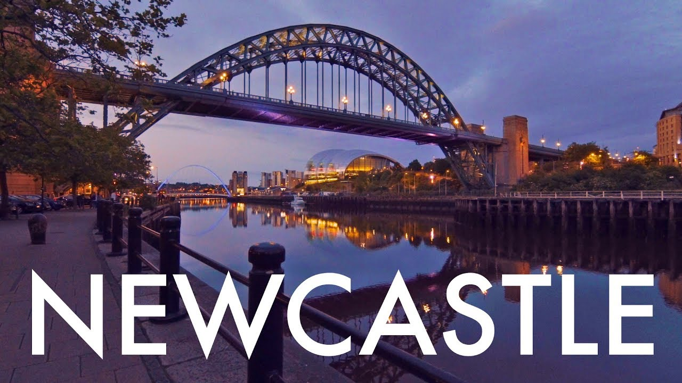

Walk with us!

The Newcastle upon Tyne bid for the 2020 UK Recovery Walk

Let us tell you about Newcastle

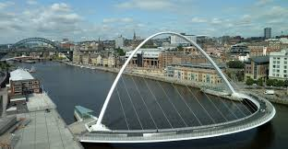
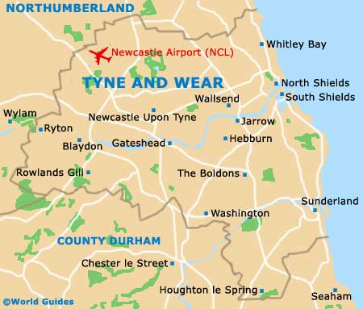

The history of Newcastle upon Tyne dates back almost 2,000 years, during which it has been controlled by the Romans, the Angles and the Norsemen amongst others. Originally known by its Roman name Pons Aelius, the name "Newcastle" has been used since the Norman conquest of England. Due to its prime location on the River Tyne, the town developed greatly during the Middle Ages and it was to play a major role in the Industrial Revolution, being granted city status in 1882. Today, the city is a major retail, commercial and cultural centre.
Newcastle is the unofficial capital of the North East. It is one of the most iconic cities in Britain, famous for its industrial heritage. It’s a thriving City and home to 477,466 people including 25,000 students (approximately). We also attract over 2 million tourists and visitors every year coming to see the beautiful mix of old and new that make this city such a wonderful place to live and to visit.
We are passionate people, proud of our history, heritage and city. Newcastle and its inhabitants are friendly and welcoming, in fact we were ranked in the top 5 friendliest Cities in England.
Newcastle prides its self on hosting events and festivals throughout the city that cover a multitude of genres. For example, the annual Newcastle Pride march, and in 2020 Newcastle will also be hosting the National Pride march. Great North Run the biggest half marathon in the world. Now in its 38 year. The Great Exhibition of the North was a two-month exhibition, celebrating art, culture, and design held in Newcastle. European rugby's showpiece finals, the European Champions Cup and European Challenge Cup.

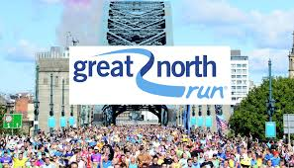
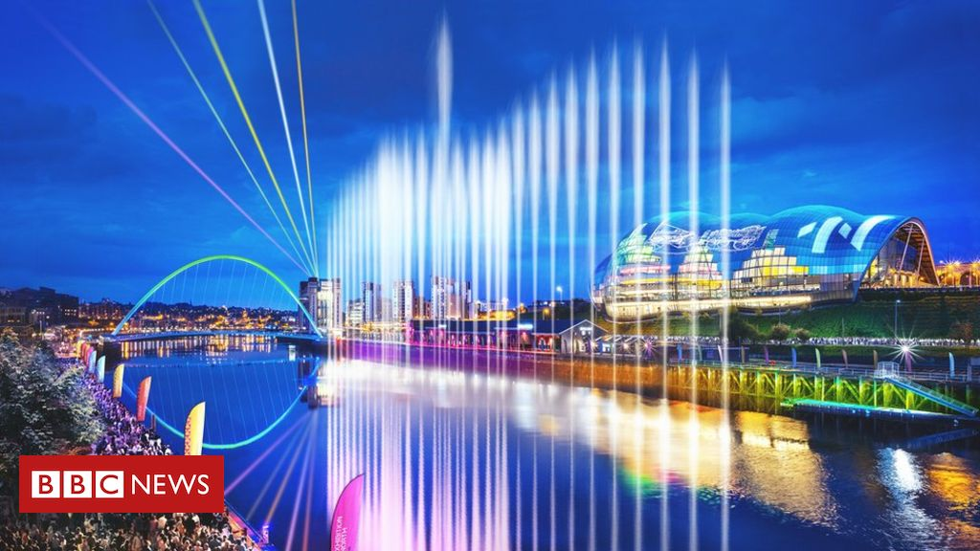
Newcastle Pride

Great North Run

Great Exhibition of the North

Rugby Finals

https://www.northern-pride.com/pridefestival/
https://www.greatrun.org/great-north-run/event-info
https://www.gateshead.gov.uk/article/7640/Great-Exhibition-of-the-North-programme-revealed
https://www.newcastlegateshead.com/whats-on/european-professional-club-rugby-finals-newcastle-2019-p975281

Our bid is supported by…

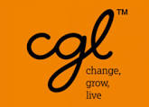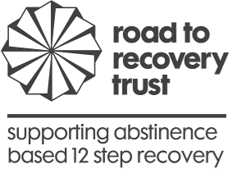

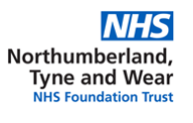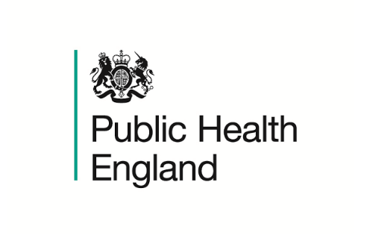

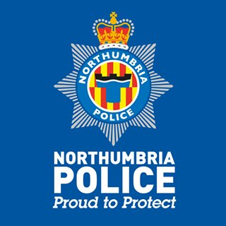

Views from the Newcastle Forum…

Having the UK Recovery Walk in Newcastle will give a really positive message of support to all the people still in active addiction. A way of empowering people to start or to continue their recovery journey. Having the walk in Newcastle for the first time will give a wonderful message of hope and strength and show how all the recovery community can come together.
The Newcastle User Carer Forum are very excited to be involved in the planning stages and working with all the services in Newcastle to make the day a “call to action”. Together we can show that the old lie is dead…
WE DO RECOVER!

Professor Eugene Milne Director of Newcastle Public Health

Hosting the Annual Recovery Walk is a fantastic opportunity for Newcastle to raise the profile of recovery from addiction and demonstrate that people can, and do, achieve that goal. Our city is moving on from its ‘party town’ image to embrace a much wider range of activities, including high-profile events with a safe and vibrant night time economy while fostering mutual aid and supporting communities. We want people to know that there is so much more here for everyone to enjoy, and we look forward to celebrating effort and success with those in recovery.

Services and support

Our local prevalence rates show 2,174 opiate and crack users (OCU) and 4,066 alcohol dependent adults in the city. We have good penetration rates for opiate users (62% engaging in structured treatment provision) however access for alcohol users is lower at 24%. In 2016/17, 26% of drug using clients, and 16% of alcohol using clients were parents living with children. We estimate at minimum 18,720 family members or carers are affected by a loved one’s use, and thus the importance of while family recovery. We also recognise the strength, value and commitment of mutual aid groups, including the fellowship, who support people through their journey and who may never access structured treatment provision.
Our Treatment and Recovery Newcastle services (TARN) are currently provided in partnership between Change Grow Live and Northumberland Tyne and Wear NTW) NHS Foundation Trust. They provide services within the city centre as well as community-based recovery support, bringing recovery to people where they need it the most; in their own communities. Our family support provider PROPS was set up in Newcastle by a group of mothers concerned about their children’s drug use and gives invaluable support to families and carers.
We are currently in a recommissioning process and have carried out a wide range of consultation events with a range of stakeholders which have helped shape our model of future delivery. We want to provide a life course approach, integrating our adult and young people offerings to give support throughout the life course of the treatment and recovery journey but also to intervene earlier with vulnerable cohorts to prevent future harms. As a city we have also protected the investment in substance misuse support, recognising the impact of reduced capacity.
We are commissioning services against our city’s Recovery Framework, which was developed in 2016 with key stakeholder, to share a local vision and ambition of recovery. This framework includes abstinence, medication and family recovery as key domains and is a resource used in a wide variety of ways.

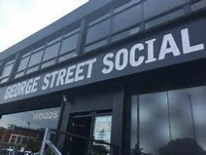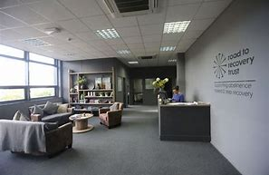

We are also very proud of our recovery café George Street Social. George Street was opened in July 2016, financed by a Public Health England grant, and is the brain child of the Road to Recovery Trust. The trust is a charity organisation set up and run by people in long-term recovery from drug and alcohol misuse. The café provides a safe and relaxed place where anyone can meet for coffee, food, amazing cakes and fellowship. Upstairs George Street hosts training courses, recovery-based activities and over 30 Fellowship meetings a week.
Our recovery community is getting bigger and more diverse. We have a firmly established Alcoholics Anonymous and Narcotics Anonymous base within the city but also have meetings for Cocaine Anonymous, Gamblers Anonymous, Emotions Anonymous, Al-Anon and SMART recovery.
We have also been able to develop additional recovery focused provision from Public Health England drug and alcohol capital grants; Ridley Villas accommodation for mothers and children; Fenham Library and Community Hub (which has been a hugely successful project placing a recovery base in the west of the city, integrating provision within a library. This initially came with some resistance from the community however with support from the fellowship and recovery groups, has enable a public discussion and focus on recovery), and latterly a grant to renovate a family and children’s centre for our substance misuse providers, alongside the fellowship, to work alongside children’s and family provision enabling early and whole family intervention.
Another key part of our recovery community is the Newcastle User Carer Forum. The forum is a meeting place for people who have experienced issues with addiction, mental health, homelessness and criminal justice. The forum is supported by Newcastle Public Health but remains independent of all service providers. Members can take part in a range of volunteer activities such as delivering workshops in Schools Colleges and Universities, sharing their experience, strength and hope with others in treatment and working with Public Health to shape the delivery model in Newcastle. They are also passionate supporters of the UK Recovery walk have attended every walk for the last 5 years and playing a very active role in the planning and delivery of the Durham walk in 2015.

Planning and delivering the walk

The walk would be organised by a cross section of people from the recovery community in Newcastle. This would include representatives from the drug and alcohol service providers, service users and carers, members of staff working in the services and the recovery community in general.
The Local Authority and Northumbria Police also take a key role, and we will follow usual process for Safety Advisory Group planning for events. This cross section of involvement will give us a wealth of knowledge and experience and the chance to share opinions, best practice and learning. Several of the representatives have experience of previous recovery walks and organising some of the City-wide events in Newcastle that were mentioned under the ‘Let us tell you about Newcastle’ section of the bid, and of course the city has great experience of this kind of walk.
The ability to be truly co-productive is key. With the experience, knowledge and passion that we will have in the organisational team we know that we will be able to deliver a UK Recovery Walk that will be a credit to Newcastle and the FAVOR.
Newcastle will continue to use the UKRW logo and branding on all merchandise and materials associated with the walk. In partnership with local businesses and community groups we are in the process of attracting more funding and potential sponsorship agreements. All supporters and suppliers would be aware of, and bought into the underlying values of the recovery movement and the UKRW charity.

Conference

We have a looked at several possible venues to host the UK Recovery Walk across the City. Our proposed venue is Newcastle College. The College is situated only 10 minutes walk from the City centre and the train station. There is a large lecture theatre perfect for the main conference and there is access to other smaller rooms that can be used for “break out” meetings.
We have excellent links with the College and the venue has hosted the Regional Service User Conference. The Newcastle Service User Forum has worked with the College for a number of years delivering drug and alcohol awareness sessions to pupils and staff.
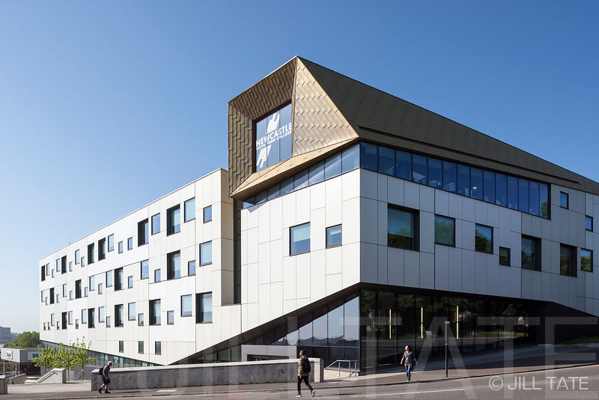
Attendance registration for the Conference is set at the rate of £50 for professionals, £10 for friends of recovery or guests and FREE for those in recovery.
We have illustrated within the financial report scenarios where we have 50 delegates made up of 15 professional and 35 recovery places.100 places with 30 professional and 70 recovery places. And 200 places with 60 professionals and 140 recovery places.
The lecture theatres, college library and break out rooms and areas will give us more that adequate space to accommodate all conference attendees.

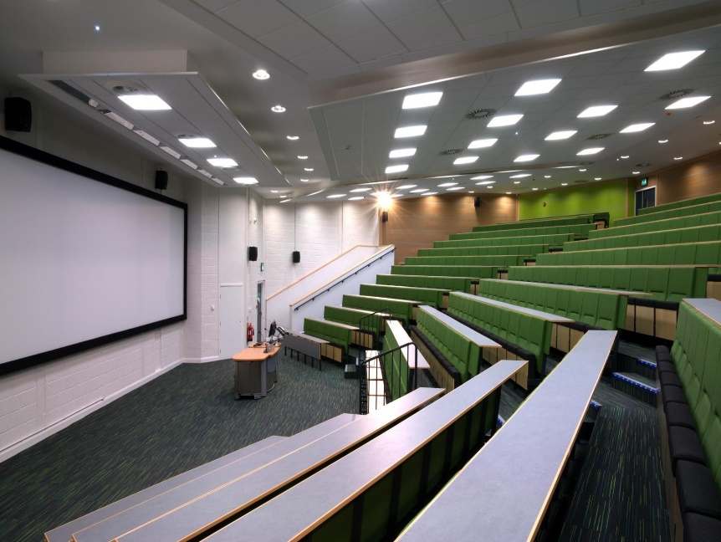

Church Service and Sleep Out

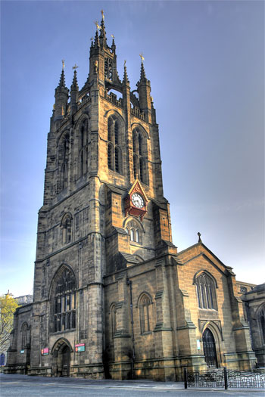
The Cathedral Church of St Nicholas. Is located in the centre of the City and within walking distance of the Central train station and a Metro station. The Cathedral has opened its door in the past to the recovery community for a sleep over and we are very keen to carry on this tradition of the UK Recovery Walk here in Newcastle. There will be refreshments provided to those sleeping in the Cathedral

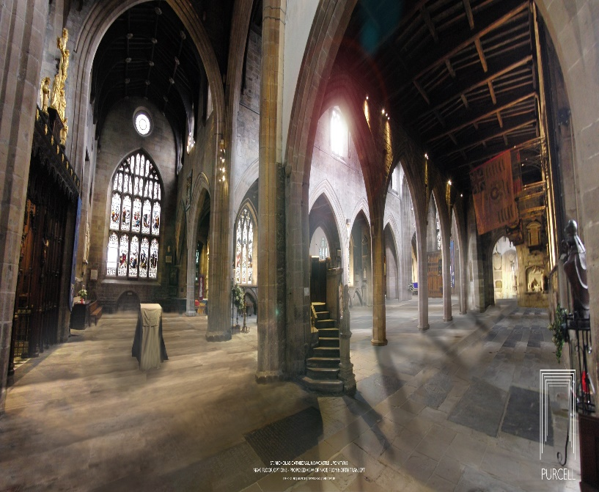
The Cathedral will offer a recovery church service on the Friday of the sleep over. Open to anyone who would like to attend.

UK Recovery Walk 2020 Route

The walk will begin and end at Exhibition Park. The route itself will take in as much of Newcastle City centre as possible. We want to show the centre of our city to our visitors and at the same time show the residents of Newcastle the strength, passion and size of the recovery community. The walk is very similar to the well-established route that is used for the Newcastle Pride festival march.
From Exhibition Park we will make our way down to Newcastle Civic Centre allocated in the Haymarket area. It is the main administrative and ceremonial centre for Newcastle City Council. Designed by the city architect, George Kenyon, the building was completed in 1967 and was formally opened by HM King Olav V of Norway on 14 November 1968. It is a Grade II* listed building. The Newcastle Civic Centre is the joint eighth tallest building in the city, and stands a total of 200 feet (61 m) tall.

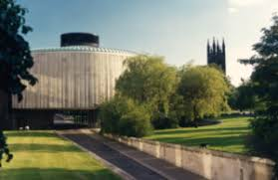

As the walkers pass Newcastle University the route then takes us into the heart of Newcastle’s shopping area, Northumberland Street. A pedestrianised street it’s home to some of the major high street retailers as well as cafes, eateries and a variety of independent street traders.
Turning right at the bottom of Northumberland Street and onto Blackett street the walk passes the entrance to Eldon Square and Grey’s Monument.
Grey's Monument is a Grade I listed monument to Charles Grey, 2nd Earl Grey built in 1838. It was erected to acclaim Earl Grey for the passing of the Great Reform Act of 1832 and stands at the head of Grey Street. It consists of a statue of Lord Grey standing atop a 130-foot-high (40 m) column. The column was designed by local architects John and Benjamin Green, and the statue was created by the sculptor Edward Hodges Baily (creator of Nelson's statue in Trafalgar Square).
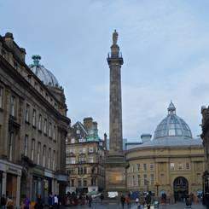

On the right will be New Eldon Square, which during the Summer will be transformed into a family friendly fairground for 6 weeks. To give the street a park-like feel, 1,000sq m of artificial grass will be placed on the road from Old Eldon Square to Pilgrim Street for the duration of the weekends, while an avenue of trees will run along the north side of Blackett Street. Bean bags, mini deck chairs, and an artificial grass sofa will also be brought out to make the street more accessible to both adults and children.
The idea for the fairground was devised by Newcastle’s Business Improvement District NE1, which organises a range of programmes to bring people into the city centre. These include Alive After Five, the Quayside Seaside, Newcastle Motor Show, and Restaurant Week.

Turning right again the route loops back, this time passing Newcastle University on the left-hand side before turning left at Claremont Road. On the right-hand side will be the Great North Museum Hancock.

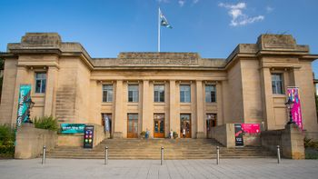

The Great North Museum: Hancock is a museum of natural history and ancient civilisations. The museum was established in 1884 and was formerly known as the Hancock Museum. In 2006 it merged with Newcastle University's Hatton Gallery to form the Great North Museum.
Passing the Museum, the walk will then continue back into Exhibition Park base for the festival celebrations.

UK Recovery Walk 2020 Festival Celebration

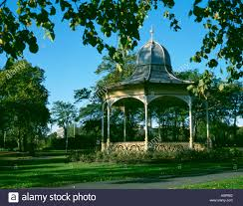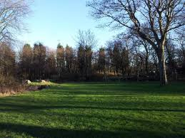

Newcastle Exhibition Park is situated at the Town Moor recreational ground. It was first used during the Jubilee Exhibition 1887. The park offers a range of facilities and still has the original bandstand from the 1887 Exhibition.
The Town Moor is a large area of common land in Newcastle upon Tyne. It covers an area of around 1000 acres and is larger than Hyde Park and Hampstead Heath combined, and also larger than New York City's Central Park. Like them it is not on the edge of the city, but has suburbs all around it. It stretches from the city centre and Spital Tongues in the south out to Cowgate/Kenton Bar to the west, and from Gosforth to the north and Jesmond to the east.
At the south-eastern corner lies the Exhibition Park, but the rest of the Town Moor is not laid out as a park and is mostly treeless. Freemen of the city have the right to graze cattle on the moors, and every June it is home to the Hopping’s the biggest traveling fair in Europe.
This space will be the start and end of the walk and here we will have a celebration event featuring bands and speakers on stage, stalls and wide range of food and refreshments. The perfect base for everyone attending the Recovery Walk 2020 spend their day in Newcastle.

Getting to Newcastle

By Train: Newcastle Central Station will take all attendees to the very heart of the city with accommodation and Recovery Walk events in walking distance.
For 24-hour train information you can call 03457 48 49 50 or visit:
www.tpexpress.co.uk
www.nationalrail.co.uk
www.virgintrainseastcoast.com

By Car: Post Code for the walk site NE2 4PZ
From the South – Take the M1 and then the A1(M). Continue on the A1(M) to Great North Road/B1318 in Newcastle Upon Tyne. Take the exit for the B1318 from A67(M) Merge onto the Great Road
From the North – Follow the A1 to the Great North Road/B1318 in Newcastle Upon Tyne. Take the A1056/B1318 exit from A1. At the roundabout take the 2nd exit onto Great North Road/B1318

By Bus: National Express coaches are available from throughout the country to Newcastle coach station which again is situated in the heart of the City. For more information call
+44 (0)8717 818178 or visit the www.nationalexpress.com

Accommodation in the City

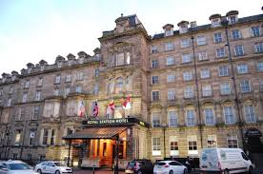
The Royal Station Hotel
The Royal Station Hotel, Newcastle is a grade 1 and 2 Victorian listed building boasting elegant architecture, officially opened by Queen Victoria in 1850. Today, we offer spacious rooms, an indulgent bar and restaurant, an indoor heated swimming pool and a fitness centre within its iconic walls. There is a choice of all room types at the Royal Station and prices are approximately £50 per night.

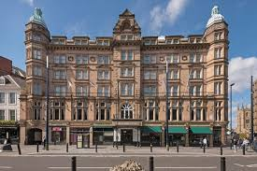
The County Hotel
The County Hotel is one of Newcastle's original hotels dating back to 1874, located directly opposite Newcastle train station and within close proximity to the main shopping spots, museums and cultural attractions. There is a choice of all room types at the Royal Station and prices are approximately £52 per night.
The Station and County are the closest hotels to the Central Station. However, there are a huge range of hotels and B&B’s available across the city with an average price of £12 per night.

Summary
This is an exciting opportunity to show the world that our city is so much more than a party venue.

It is a chance to promote health and well-being, increase awareness about addiction, promote fellowship and begin to dismantle the stigma which creates such obstacles to transformation. Furthermore, it is a chance for the Recovery Community to join together with all the supporting agencies, families and friends to fly a flag in celebration of lives saved.

Newcastle are committed to deliver a recovery walk that will show not only the faces and voices of recovery in Newcastle but the faces and voices of recovery across the country. All will be the catalyst to help Newcastle become a true recovery city!

Source: Estimates of prevalence of opiate use or crack cocaine use 2016/17 Public Health Institute John Moore’s University

