A cabaret by a New York actor and musician, who is in recovery from substance addiction, is to be held in Glasgow on Monday 30th September.
Tara Bruno says she hit rock bottom five years ago and has managed to turn her life around after seeking help.
Her performance will raise money for the national charity Faces and Voices of Recovery Scotland (FAVOR).
Tara, who moved to Scotland and attained a Masters in Acting at the Royal Conservatoire of Scotland, said: “I owe it all to my recovery. Now that my studies have ended, I’d like to give back by making a small contribution to help the ongoing organising of community voices.”
Annemarie Ward, CEO of FAVOR, said: “We are so grateful to Tara. She is an inspiration and we know she is incredibly talented, too. It promises to be a fantastic and quite emotional evening.”
As well as an opening cabaret, with songs written by Tara, there will also be a half hour set by local comedian, Amelia Bayler.
Tara said: “People will have the chance to donate to the charity throughout the night. Everyone is welcome. The event is a suggested donation of £10 or a pay what you can at the door.”
She continued: “I’ve met the most incredible people in recovery across the world. People have my back, and I don’t have to go through life alone. Raising awareness that recovery is possible by making my own visible feels like a calling.”
The benefit will be held at STEREO in Glasgow at 8 pm, 22-28 Renfield Ln, Glasgow, G2 6PH.
ENDS
NOTE TO EDITORS: The latest statistics on Scotland’s drug-related deaths make for shocking reading. 1187 drug-related deaths were registered in Scotland in 2018, 253 more than the previous year. This represents a 27% increase since 2017 and is more than double the figure for 2007. Deaths have been at record levels for five years in a row. At 21.98 deaths per hundred thousand people, Scotland’s drug death rate is now:
- The highest drug death rate in the EU
- A higher drug death rate that the USA (21.7 per 100k in 2017)
- Over fifty times that of Portugal’s (less than 0.4 deaths per 100k in 2016 )

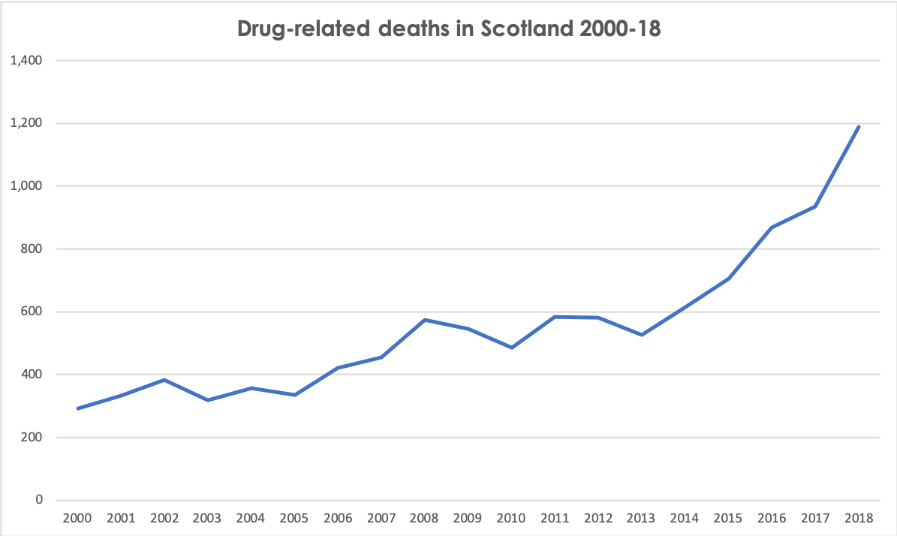
Most drug-related deaths involve more than one substance.
- Heroin and/or morphine was implicated in 45% of the total – 537 deaths.
The number of deaths was more than ever before for:
- 1021 deaths from Opiates (e.g. heroin/morphine) or synthetic opioids (e.g.methadone/fentanyl) as a group
- 792 deaths from Benzodiazepines as a group (previous highest 552 in 2017)
- 273 deaths from Cocaine (previous highest 176 in 2017)
Annemarie Ward from Faces & Voices of Recovery UK said: “Each & every one of the UK’s drug deaths are an avoidable tragedy, and the failure of our treatment systems, politicians in Westminster and Holyrood to act is an abhorrent catastrophe . This public health crisis is a consequence of a one size fits all, woefully inadequate treatment system, socially inadequate conditions, poverty, and a class issue. Faces & Voices of Recovery welcome this courageous, heartfelt tribute from performers who have in their own words narrowly escaped their own catastrophes. A night to celebrate those who have embraced their own recovery Journeys, to add strength to sustaining it and to bring together our families to honour those we have lost.
For media enquiries please contact [annemarie@facesandvoicesofrecoveryuk.org]

Notes to editor:
About Faces & Voices of Recovery UK
Faces & Voices of Recovery UK are a national charity, made up of individuals in recovery, their friends and families and Community Recovery Organisations.
We are a policy advocacy movement that is taking on issues of discrimination, social justice and service access. A public and professional education movement, intent on challenging stigma.
Faces & Voices of Recovery UK is dedicated to organising and mobilising:
- the recovery community in recovery from addiction to alcohol and other drugs
- our families, friends and allies into recovery community organisations and networks.
For further information about Faces& Voices of Recovery UK’s work or to find out how to support the charity, please email info@facesandvoicesofrecoveryuk.org or visit www.facesandvoicesofrecoveryuk.org. Follow us on Twitter and Facebook.

