Part A: UK Recovery Walk
The status of local community recovery groups and any service structure
ReNew is a free and confidential drug and alcohol service for adults, families, carers and affected others in Hull.
We have three unique hubs in Hull, dedicated to providing an end-to-end facility and support for adults who may have drug or alcohol issues.
What we offer

- Expert advice and information on drugs, alcohol, homelessness, prison and how to improve your health and wellbeing.
- A multi-disciplinary approach to care; our team includes experienced health and care staff, nurses and doctors.
- A whole family approach – working holistically with all members of the family to achieve and promote recovery.
- Therapeutic group and 1:1 interventions.
- A community and inpatient detoxification provision.
- Access to residential rehabilitation environments.
- A comprehensive harm reduction offer - reducing drug related deaths and harm via blood borne virus screening and issuing emergency lifesaving overdose reversal medication (Naloxone).
- Education, training and employment services – with direct links to all local education providers and an in-house community training provision.
- Multiple connecting communities offers, including – an outreach provision, a rough sleepers’ provision, criminal justice provision and a provision exclusively for women.
- Multiple peer led support provisions, including; Alcohol Anonymous, Narcotics Anonymous, Gamblers Anonymous and a daily breakfast club which is free and open to everyone.

In addition to this, independent of ReNew, there are 8 NA groups, 9 AA groups, the CA group and we have Polish and Russian equivalents of each; as well as the Youth Project, Men in Sheds, SMART Recovery and multiple faith groups that provide assistance.
ReNew are located
- 41–45 Beverley Road, Hull, HU3 1XH (4 minute walk from the train station)
- 728-730 Hessle Road, Hull, HU4 6JA
- 74 Goodhart Road, Bransholme, Hull, HU7 4EF
Estimated size of local recovery community
260,000 people live in Hull. 2,300 open to ReNew – with an estimated 1,500 in the aforementioned groups in the community. There have been consistent figures reported by the local authority in the last several public health briefings, The highest figures in the last decade were reported, as follows: “In Hull it is estimated that there are around 9000 non-class A (cannabis, mcat, ‘legal highs’) adult drug users, of whom 22% are offered brief support. Additionally there are around 4000 habitual class A (heroin, crack, cocaine) drug users of whom 65% are in contact with specialist services.”
Relevant experience in organising conference, walks, events etc.
We have partnered with the Hull Event Safety Advisory Group (ESAG) who, in their busiest year, over 365 days, helped deliver a programme with more than 2,800 events, exhibitions, installations, and cultural activities was delivered across Hull and the East Riding of Yorkshire. Cumulatively, this programme was experienced 5.3 million times by audiences, with more than 9 in 10 residents taking part in at least one cultural activity in 2017. The group helps with:
- offering helpful advice to ensure the walk goes ahead safely
- offering guidance and templates to help with our planning
- putting us in touch with other shared-interest events and organisations
- advises us of potential clashes or issues to help us avoid pitfalls
- helping us to gain all the necessary licences or permissions for the walk
The Hull Event Safety Advisory Group (ESAG) will help us with advice and support to ensure that your event is the safest and the best it can be. They have provided us with the following guide to take us through the stages of planning a safe and successful event. It combines general advice and good-practice guidance with a handy checklist. They’ve stated that guide is not meant as an exhaustive list and can provide us with a wealth of information and point you us the direction of organisations and governing bodies that may be able to offer advice on specific types of event.
They will help gain local authority approval and road closure application as well as Codes of practice and legal requirements. They will also provide the framework and guidance for:
- Completing an Event Safety Guide, Risk Assessment, Traffic Management Plan, Contingency Plan or Evacuation Plan
- Familiarise ourselves with relevant codes of practice
- Taking out public liability insurance
- Ensuring that contractors and performers have their own insurance, risk assessments and where appropriate, CRB clearances
They will help with audience welfare needs including requirements for the following:
- toilets
- first-aid
- provision for young children (baby changing, lost children)
- provision for deaf or disabled
- visitors
- rest areas
- refreshments
They will also help us create an emergency plan – to cover contingencies for inclement weather and no-shows by contractors or performers, as well as the more obvious how to deal with fire, flood, bomb scare etc.
They have also provided us with a checklist, too;
- Identified aims and objectives for event
- Established when, where, when etc
- Sought and been granted appropriate permissions and licences
- Risk Assessment completed and under continuous review
- Identified public facility requirements
- Acquired Public Liability Insurance
- Created an Event Plan
- Established organising roles and responsibilities
- Contacted ESAG
- Drawn up site plan
- Emergency Plan created, communicated and easy to access during the event
- Temporary structures booked and safety credentials identified
- Catering organised and safety credentials checked
- Personnel recruited
- Needs of those with a disability considered and catered for
- Parking arrangements made
- Relevant individuals and authorities informed
- Arrangements for clearing up put in place
- Inspections conducted
- Signage in place
- Personnel briefed
We have links with the PRIDE team here who are willing to share with us access to entertainment and interactive activities for all ages, including live music, a children’s programme including inflatables, sports and fitness challenges and arts and crafts. Much like other walks, there will also be a recovery focused community village, holistic healing therapies, food vendors and a recovery meeting tent based in Queen’s gardens. We have an existing “Hull Street Food” collective that provide a wide range of hot food and drink taking inspiration from all over the world, in an open-air setting.

Reasons why the area/region wants to host the UK Recovery Walk
The primary reason for us wanting to host the Recovery Walk is for the benefit to our local recovery community. For too long, Hull has been ignored, voted “the worst place to live in the UK” and is the target of many derogatory jokes - that’s a frustration felt by people not in addiction, let alone people potentially going through the most difficult time in their life. As mentioned in our note of interest; the city’s declining industry and relative geographical isolation (being at the end of the M62 - with 63 miles to the next big city) Hull is often overlooked for national events. These difficulties have fostered perceptions of the city that are deeply linked with poverty, urban decay, and social and economic disadvantage.
Our ReNew service has worked hard to challenge what the public perception of addiction to substances looks like through social media rich campaigns. With the launch of the ‘Believe in People’ videocast in 2022 we have helped tackle stigma by speaking with people who have suffered with a poor relationship with substances. This includes those who have used the ReNew service to achieve recovery, successful business owners, social media influencers, celebrities and governmental policy advisors in relation to drug and alcohol treatment. With this resource receiving close to one million hits in engagement over different platforms we believe that hosting the Recovery Walk will be complementary to what we are achieving in a digital environment and bringing it to a physical environment - further empowering our recovery community. It’d be a legitimate delight to out service users to see local landmarks whilst celebrating their success.
Furthermore, as Hull hasn’t had anything “visible” in terms of active public participation relating to addiction and recovery, this walk will act as conduit to increase the local population’s understanding of the links between trauma and the use of alcohol and other drugs, promoting the values of patience, understanding and empathy.
The route has been carefully selected, too – the inclusion of local authority establishments along the way, as well as large media establishments and running through the two most populated parts of the city means that we try and influence / shape public policy by removing the tokenism around the way that the voices of living and lived experiences are heard.
And finally, as with any public event it will; develop learning, education and skills, contribute to better health and wellbeing, increased community pride and engagement and changing perceptions of marginalised social groups.

Any branding suggestions
As our service is called ReNew – we often use words that have the same “Re” prefix
ReNew
ReSpect
ReBuild
ReThink
RePresentation
ReCovery
ReFlect
ReSiliance
ReNew have an established name in the city – we are synonymous with the work that we do so it might be that the “ReCovery” in Recovery walk matches the “ReNew” in terms of typeface – people that are linked with this sector will instantly recognise the nature of the walk.
When the City hosted the City of Culture event in 2017, one of the key branding themes was “There’s more to the story” which enabled it to both look back at its maritime, art and literary heritage while also building on its people, places and culture to create a lasting legacy for the city. This seemed to resonate well with people looking in at the City for the first time, perhaps something similar could apply to the walk, as it may be many people’s first look into this community.
We also have a few high profile participants who would be willing to promote the walk in the run up to the event, via our podcast series - To date we have had discussions with people in addiction, people in recovery, front line nurses, a Dame, a drag queen, a pop star, multiple Managers of addiction services, volunteers, frontline staff, a Professor of Medicine, leading figures in the LGBT+ community, artists, business owners, interns, students, GPs and many more - we're very lucky to have spoken with a very large cross section of people who are intrinsically linked with this sector. We have discussed; addiction, alcohol, parenting, drugs, role models, travel, work schedules, cancer, crime, money, HIV, Hep C, technology, dancing, government policy, sober sex, prisons, community projects, psychosocial interventions, religion, therapy... with many more topics to come. The walk would feature prominently in our existing campaigns with a 6 to 9 month campaign in readiness to increase attendance and participation.
A suggested walk route and potential local community and public sector agency support
The proposed route for the Recovery Walk is below:
Humber Street
Situated right by Hull's Marina and the former home to Hull's old market, Humber Street is now bustling with boutique shops, restaurants and art galleries. One of Hull’s last remaining visual connections to the industry it built its reputation and legacy upon.
High Street
High Street is Hull’s oldest street. Hull’s original city centre dates back to the medieval period. Originally a mixture of merchant homes, warehouses and pubs, the street was (until recently) the only High Street in the UK that didn’t have a single shop.
A number of Hollywood films and shows utilise this street regularly for historic settings – including the recent Enola Homes Film and upcoming episodes of The Crown to depict Victorian and World War 2 settings.
Wilberforce House, No. 25 High Street, is Kingston upon Hull's oldest surviving museum, opened to the public in 1906. It takes its name from the building's most famous resident, William Wilberforce, the Abolitionist, who was born there in 1759. The museum is dedicated to the memory of Wilberforce and his campaign to abolish the slave trade.
Gandhi Way
The Mahatma Gandhi Memorial Committee of Hull organises an annual lecture on a Gandhi related theme. This was recently named in honour of the legacy of his work in the UK.
Alfred Gelder Street
Another of Hull’s famous citizens, Sir William Alfred Gelder, had entered the architectural profession at the time of the Victorian era development of Hull. It was largely thanks to Gelder's ability and energy that Hull was a city transformed – with old buildings removed, new wide streets introduced and attractive shops and public offices erected. Under Gelder's supervision, Hull was being hailed as one of the country's finest cities with the slums and disorder of the Victorian city giving way to broad, straight thoroughfares - this part of the walk will see Hull’s Guildhall and Combined Courts Centre.
Lowgate
Another historic street in Hull, the walk will take you past ‘St. Mary’s’ an ancient church dating back to the early fourteenth century.
Silver Steet & Whitefriargate
The walk will turn on to Silver Steet and connect to Whitefriargate, one of the most historic streets in Hull, with 33 listed buildings. In 1642, King Charles I was refused entry to the town at Beverley Gate at the west end of the street, an act – it's argued – that started the English Civil War.
Queen Victoria Square
The square is dedicated to Queen Victoria, and contains numerous buildings including Hull City Hall, the Maritime Museum and Ferens Art Gallery.
King Edward Street
The pedestrianised “city centre” of Hull – arguably Hull’s busiest street – it contains major retailers, a McDonalds and the Central Library.
Albion Street & Bond Street
The future of Hull’s everchanging landscape – this street is entering the early stages of constriction for the £96m ‘Albion Square scheme’ that paves the way for 226 new homes, office and retail space, an urban park and a multi-storey car park.
George Street to Wilberforce Drive to Guildhall Road
The last few streets that serve as the perimeter for the walk’s destination – we’ll pass Hull College, Hull School of Art and Design, Hull City Council’s Adult Social Care Headquarters, Hull’s Registry Office, The BBC building and finally arrive at the Rosebowl – at the entrance of Queen’s Gardens.
Finishing in Queens Gardens.
The walk will enter through the flower gardens at street level around the "Rosebowl" fountain. Slopes and steps lead down from this area into the main area of the sunken gardens. Either side of the central avenue there are broad areas of lawn, interspersed with smaller borders filled with perennials, and another two large fountain pools. All major Hull live events take place here, with a capacity for up to 15,000 people
On the north side of the Gardens a plaque commemorates Robinson Crusoe, the famous fictional character who sailed from Hull in 1651 on the voyage that ended with him castaway on a desert island for over 28 years. The plaque includes the quotation, "Had I the sense to return to Hull, I would have been happy."
The Peace Garden, at the eastern end of the park, was installed by Hull City Council for the UN's International Year of Peace in 1986 and In August 2017, a £310,000 sculpture, Solar Gate, was installed in the gardens as part of the public realms work for the UK City Of Culture.
The walk is approximately 3 miles and takes between 45 and 60 minutes to complete. There are also ample opportunities to modify or change the route due to Hull’s pedestrianised area – parts of this route are used on other similar events throughout the year – including the 10k run, PRIDE event and Santa’s sleigh ride!
The event would be supported by the Hull Event Safety Advisory Group (ESAG).
Part B: UK Recovery Walk Conference
We have reserved two venues in readiness for the Conference (every Friday in September 2023) and have another two provisional bookings (not listed below, they wanted a cash deposit but acknowledge that we’re first in line and will happily delay until March 31st, if needed). Jubilee Central is a very close working partner with ReNew and we regularly use their facilities (Main Auditorium) for our own conferences.
Jubilee Central - 3 rooms suitable.
1. Queens Hall
Theatre Style Capacity: 120
Banquet Style Capacity: 90
Classroom Style Capacity: 50
PA: Fully Integrated
Projection: Integrated System

2. Larkin Room
Theatre Style Capacity: 40
Classroom Style Capacity: 26
PA: Portable System Available
Projection: Portable System Available

3. Main Auditorium
Capacity: 630
Seating: Fixed Theatre Style
Stage: Large Platform
PA: Fully Integrated
Projection: Integrated System
In house buffet and drinks available at £13 per person.
£250 per day
Holiday Inn
Myton Suite
Capacity: 120 people
Price: £500.00
Parking: 120 Parking Spaces
Features:
• Wifi
• LCD projector
• Whiteboards
• Air Conditioning
• Tea/Coffee are charged £3.00 per person per serving
• Sandwich platter lunch, £11.95 per person, served with chips, salad, fruit, and a sweet treat.

Housing accommodation - different category hotel rates; access to host town (by air, road, rail etc.)

Hotels
Premier Inn – Hull city centre - £101
Travel Lodge Hull central – £71.99
Holiday Inn express – £79.00
The Hilton hotel – £118
The Ibis – £86
The royal hotel – £135
The Gilson hotel - £60.00
The Campanile hotel - £36
Each of the 8 hotels listed are within a 10 minute walking distance of the walk.
You can book directly through hotel website or through booking.com for discounted rates.
Travel
Rail:
Hull is very well connected by rail with links from the North and Scotland. There are regular direct trains from London which take as little as two and a half hours.
Northern Railway - Advance tickets are great value you can purchase Single (one-way) tickets prior to your visit. Book ahead to take advantage of these great value fares. Advance tickets are made available by train operators up to 8 weeks ahead of travel but, subject to availability. You can still get a last-minute bargain up to 5 minutes before travel online and up to the day before in ticket offices. The earlier you buy, the lower the price.
Rail Station Car Park - 280 spaces Monday to Friday – 24 hours Saturday – 24 hours Sunday
Cycle Storage Availability - Storage location: Platforms 2 & 7
Taxi Rank - The nearest taxi rank is outside the station.
Park & Ride Bus –
Reasons to use Park & Ride in Hull:
- Free parking, you just pay for your bus ticket
- Frequent bus services, running between 06.30am – 18.40pm Monday-Friday and 06.30am – 18.20pm on Saturdays
- On-site security, they will look after your car whilst you're gone and we have CCTV on our buses
- Comfortable – wait for your bus to arrive in our refurbished waiting room, with toilets and baby changing facilities
- Convenient low floor buses which provide easy access and space for buggies and wheelchairs
- The Route - Park & Ride service runs up to every 20 minutes between 0700 - 1840 Monday-Friday and 0700 - 1820 on Saturdays
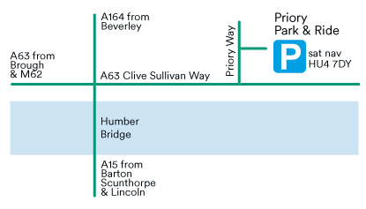
- Location: Priory Park & Ride Site, just off Priory Way. For Sat Nav users, our postcode is HU4 7DY

Public Transport:
Hulls main bus operators within the Hull boundary are -
East Yorkshire Buses
Stagecoach
National Express
https://www.eastyorkshirebuses.co.uk/
https://www.stagecoachbus.com/
https://www.nationalexpress.com/en

Once you reach Hull Paragon Interchange there’s multiple ways to get to Wilberforce drive, you can drive to where the proposed route is taking place which will take 8 minutes: 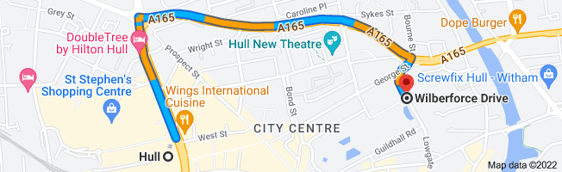
Directions by foot from Hull Paragon Station to Wilberforce drive, which will take 21 minutes: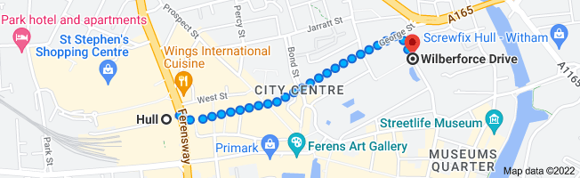

Taxi: Taxis are available at the Hull's Local Interchange Station. Taxis are also available through Drive Private Hire & Taxis.
Hull’s largest taxi firm:
Drive: 01482 575757
Other Taxi numbers:
Hull Cars: 01482 828282
35 Taxis: 01482 353535
Car parks:
- Prospect Centre
- St Stephens
- Hull City Council Car Parks
For live travel information visit traffic-update.co.uk
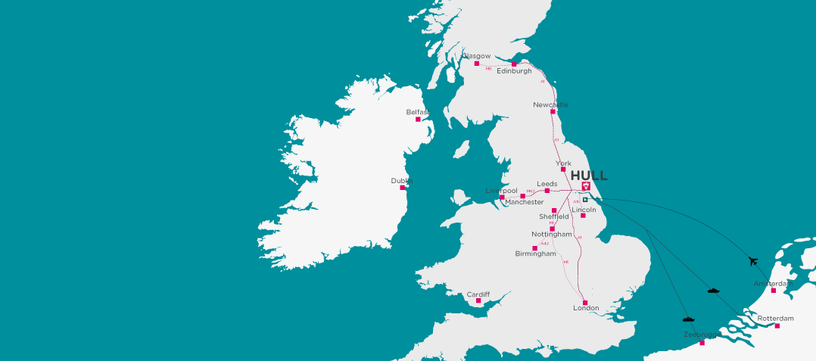
Access to Hull by Air (Humberside Airport):
The cheapest way to get from Humberside Airport (HUY) to Hull is to drive which costs £5 - £8 and takes 25 min.
The quickest way to get from Humberside Airport (HUY) to Hull is to taxi which costs £40 - £55 and takes 25 min.
The distance between Humberside Airport (HUY) and Hull is 11 miles. The road distance is 20.1 miles.
There are 511 hotels and B&Bs listed between Humberside Airport and Hull with prices start at £75 per night.

