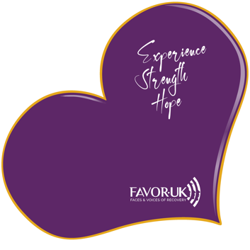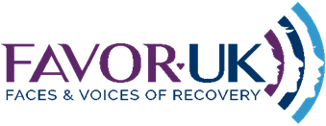

FOR IMMEDIATE RELEASE

FAVORUK annemarie@facesandvoicesofrecoveryuk.org
Tel: 07727255808
Website:www.facesandvoicesofrecoveryuk.org

Full report & PP presentation & notes can be found

https://www.facesandvoicesofrecoveryuk.org/unveiling-scotlands-sudden-death-crisis-a-live-presentation-event/

FAVORUK to Host Urgent Live Presentation on Scotland’s Sudden Death Crisis

Faces and Voices of Recovery UK (FAVORUK), a leading charity specialising in addiction recovery advocacy, announces a vital live-streamed presentation titled “Scotland’s Sudden Death Crisis: Unveiling the Truth,” set to take place on Monday, April 15th at 11 AM on their Facebook page.

This crucial event comes in response to Scotland’s escalating crisis of sudden, avoidable deaths, with a spotlight on the disturbing rise in drug-related fatalities. The presentation aims to shed light on systemic failures and advocate for transformative changes within Scotland’s investigative and social support frameworks.

Event Details:
- Title: Scotland’s Sudden Death Crisis: Unveiling the Truth
- Date: Monday, April 15th
- Time: 11 AM
- Location: FAVORUK Facebook Page

Expert speakers and affected family members will come together to present a comprehensive analysis of the current state of sudden death investigations in Scotland. They will discuss the data, share personal narratives, and propose actionable steps forward. This presentation is not only an exposition of the crisis but also a rallying cry for public engagement and policy reform.

Anne-Marie Ward, CEO of FAVORUK, stated, “This presentation is an essential step in confronting a crisis that has long been overshadowed. We invite the public, policymakers, and community leaders to join us in this critical conversation that we hope will lead to real and lasting change in how our nation deals with sudden deaths.”
Stuart Graham presenting at the event who lost his son said “I am grateful for getting the opportunity to share this package and hope it can kick start an important change that is needed and
Should be important to every family in Scotland.”

About FAVORUK: FAVORUK is a charitable organization at the helm of advocacy for addiction recovery services. Dedicated to policy reform for increased access and choice in addiction services, FAVORUK is committed to empowering individuals and communities affected by addiction. Through public education, support, and community involvement, FAVORUK seeks to foster a more compassionate and proactive response to addiction recovery.

Join Us: Members of the press, stakeholders in health and social care, and the general public are encouraged to attend this live event. For more information, please contact us at the details above
End

Note to Editors: For interviews, quotes, or more detailed information about the event and FAVORUK’s work, please use the contact details provided above.

